PROJECT DEVELOPMENT

ROBOBOX PROJECT

Members: Rick, Dmitry, VJ, Wapas

Table of Content:

* Backstory
* Unique Features
* Target Audience
* Art Assets
* Reference
* Blueprint Code
* Screenshots

Backstory: In the near future, human and robots live together. We have achieved new level of technology. While most of our industry have replaced human with robots, some people using robots for entertaining. That is how Robobox tournament is founded. Japanese team become the champion for years with their ultimate boxer Red_Cyclone. Now they challenge the whole world to beat them in the next tournament.

Unique Points:

* The new controller has two joysticks, one for moving and one for multiple punching action.

Target Audience: E rating for everyone – no gore, enjoyable story for both children and adults.

Art Assets:

* First Sketch:

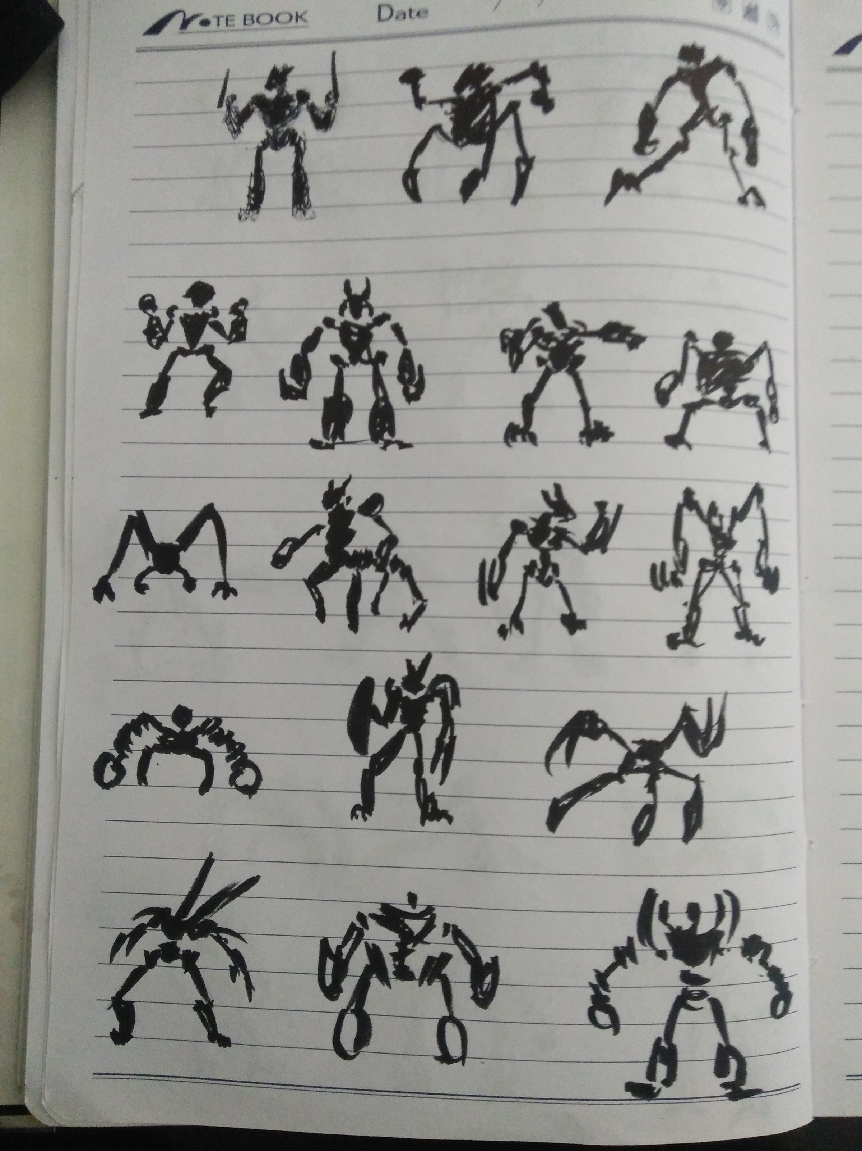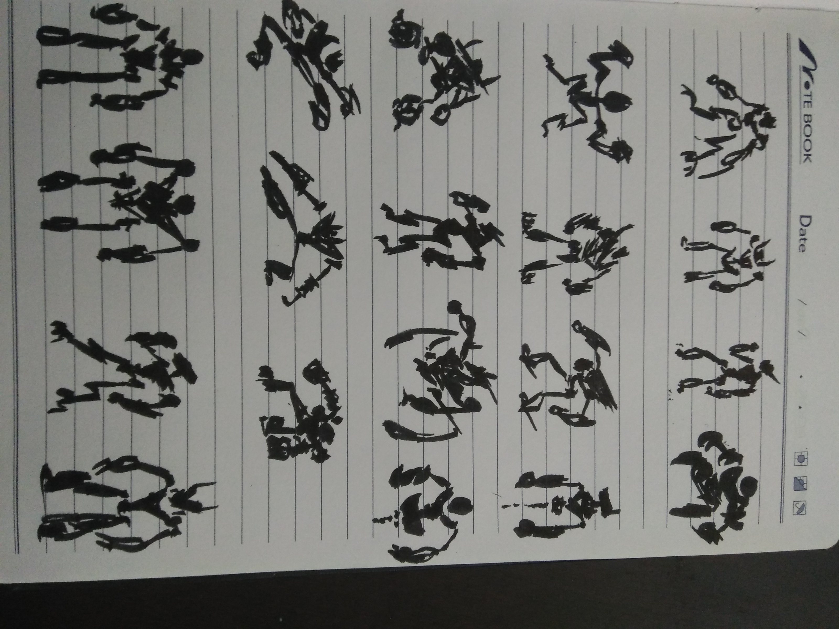

* ZBrush Sculpt:

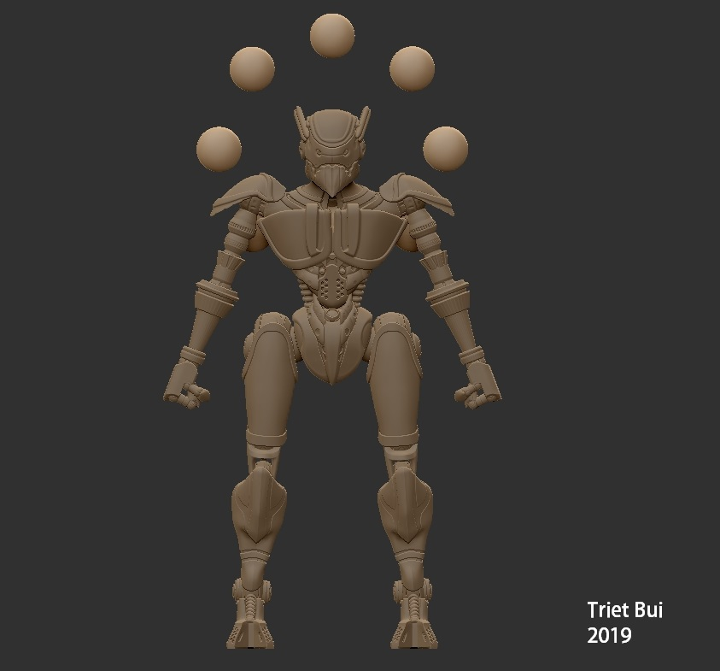

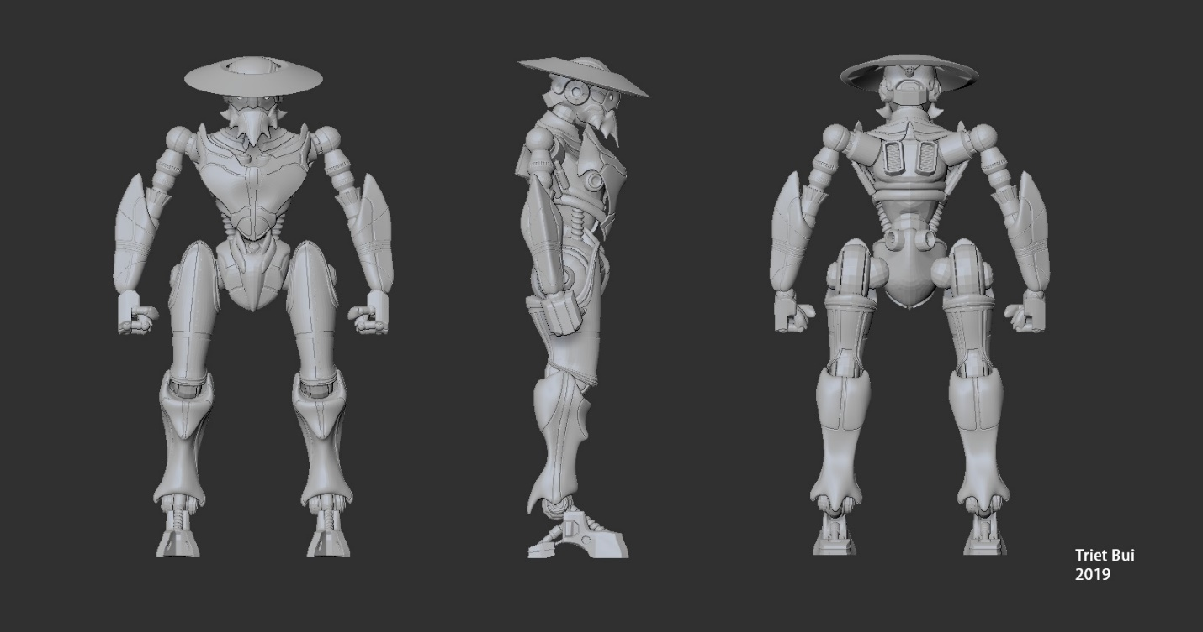

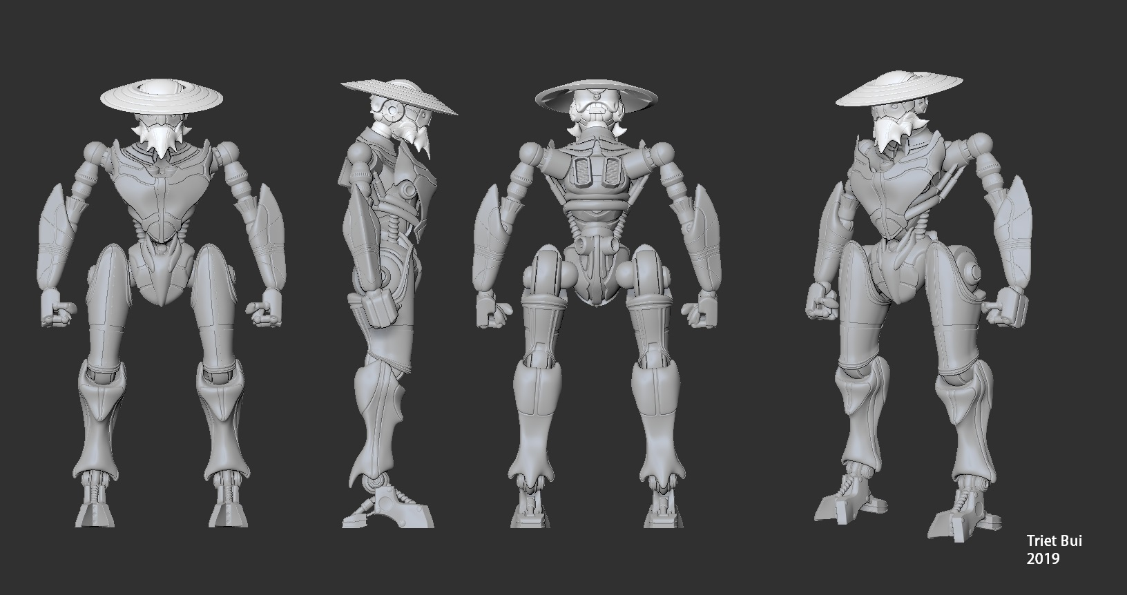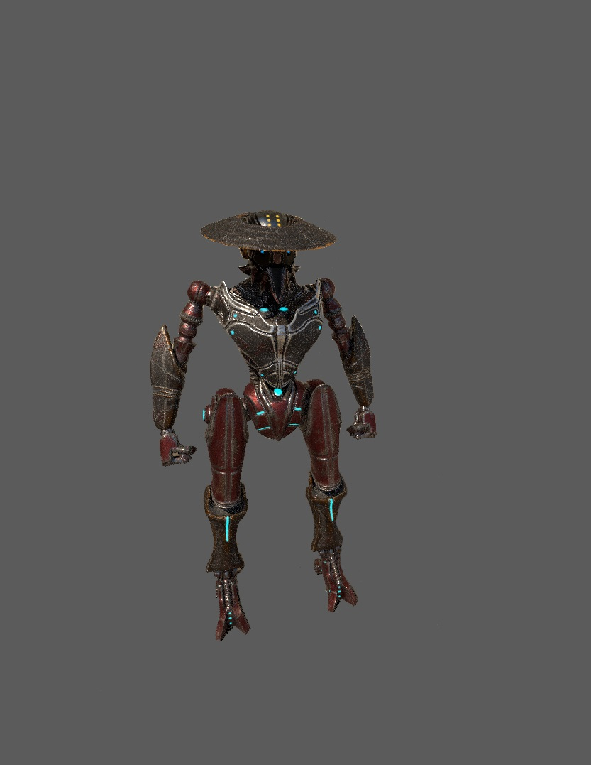

Reference:

* Robot concept arts (random from google, credit to the owners)

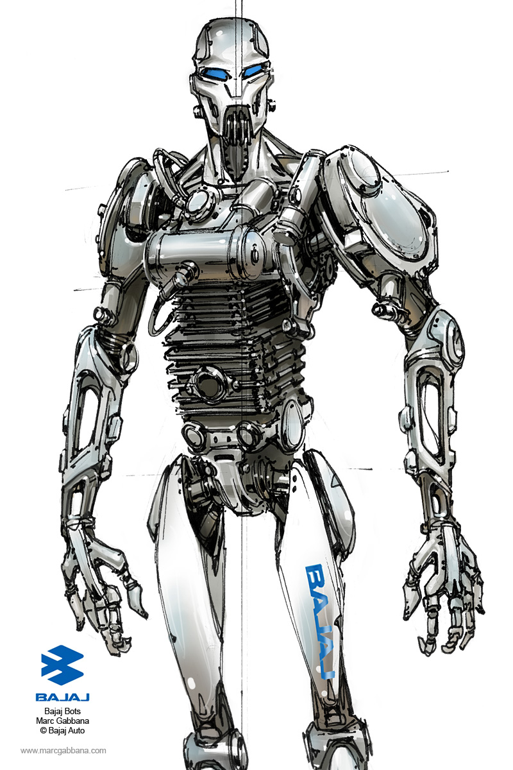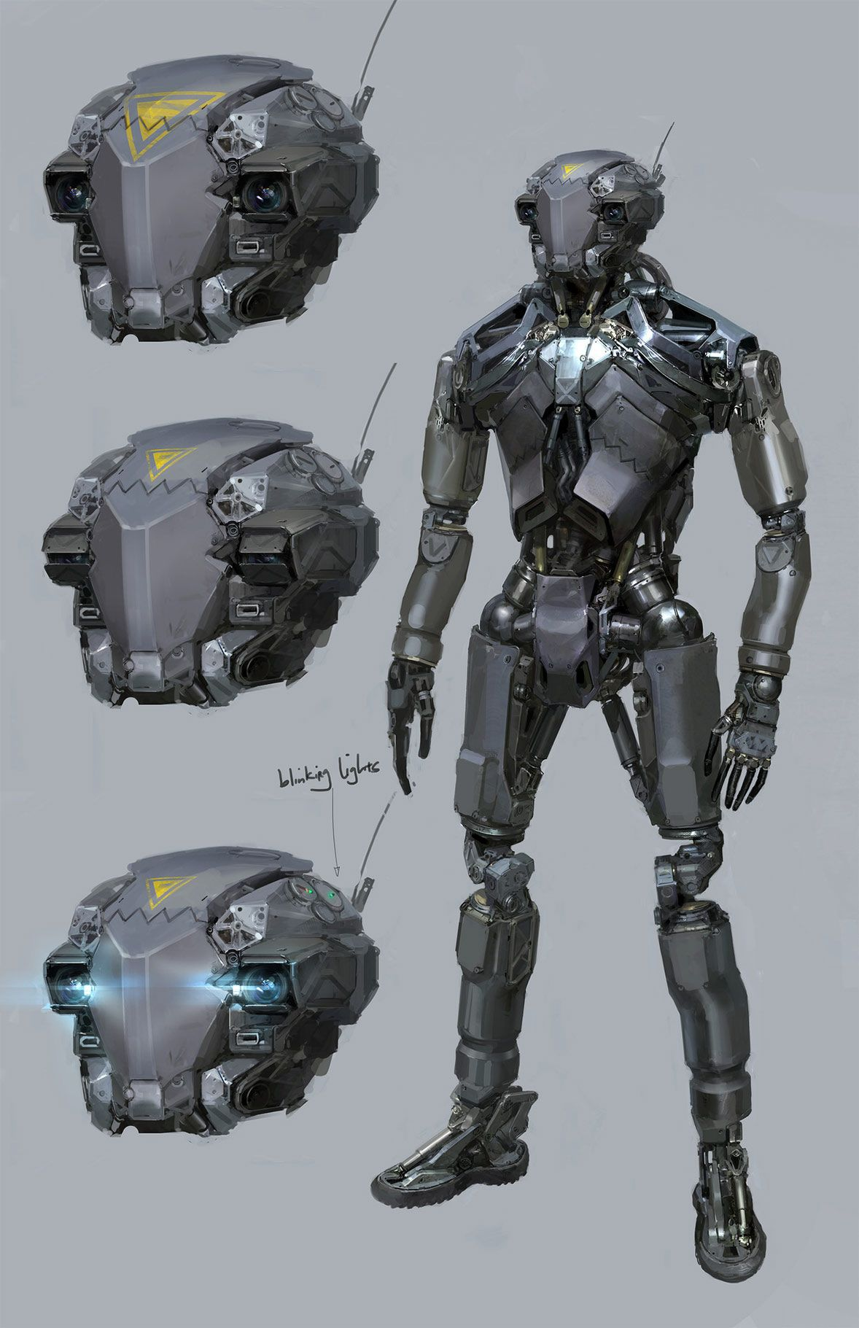

<https://www.google.com/search?q=robot+concept+art&rlz=1C1GCEA_enUS833US833&source=lnms&tbm=isch&sa=X&ved=0ahUKEwi1mKerq_jhAhVNcq0KHeYqA7UQ_AUIDigB&biw=1920&bih=920>

* Shaolin Monk

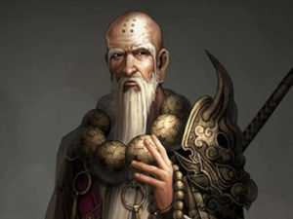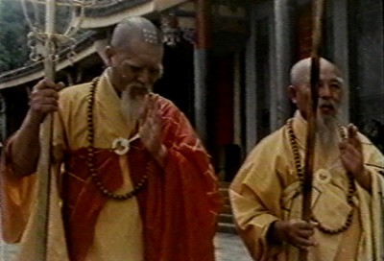

<https://www.google.com/search?rlz=1C1GCEA_enUS833US833&biw=1920&bih=920&tbm=isch&sa=1&ei=qoXIXKy_KYywtQXL5JzYBg&q=shaolin+monks&oq=shaolin+monks&gs_l=img.3..0l10.2601.2601..3280...0.0..0.50.50.1......1....1..gws-wiz-img.r73RwwKPA1c>

* Real steel – robot boxing

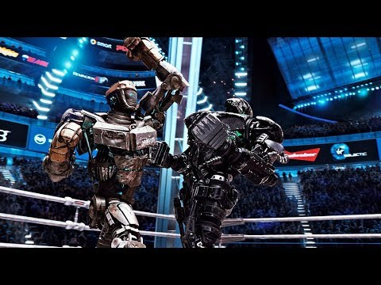

<https://www.google.com/search?q=boxing+robot&rlz=1C1GCEA_enUS833US833&source=lnms&tbm=isch&sa=X&ved=0ahUKEwj94p75q_jhAhUFSa0KHXScAZEQ_AUIDygC&biw=1920&bih=920>

Blueprint Code:

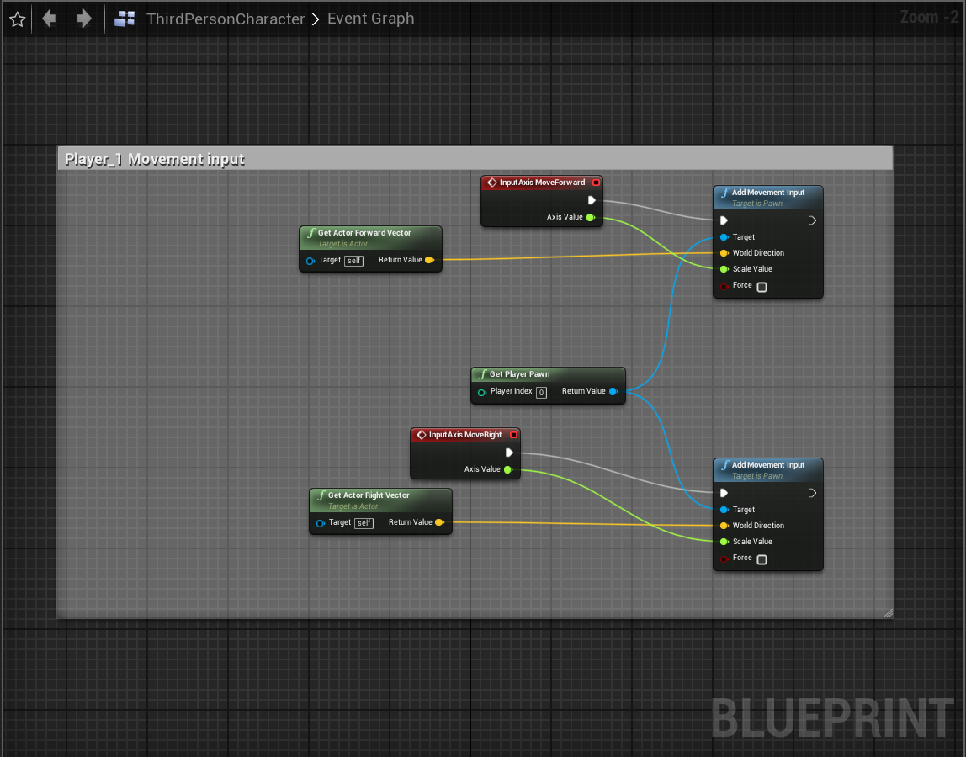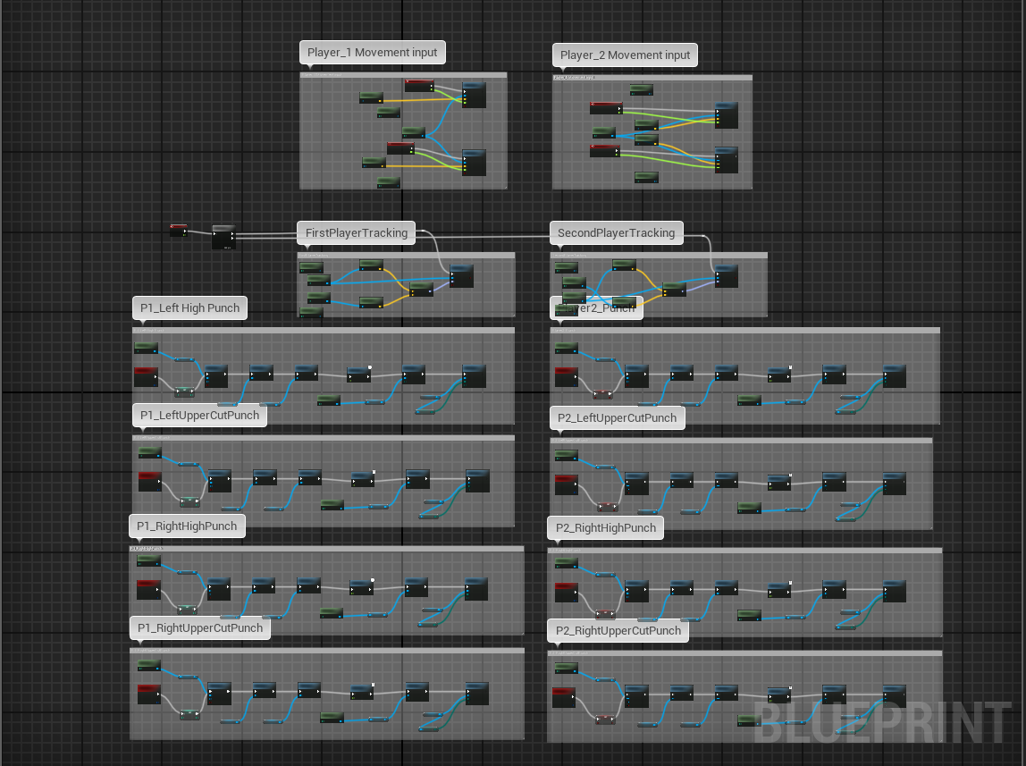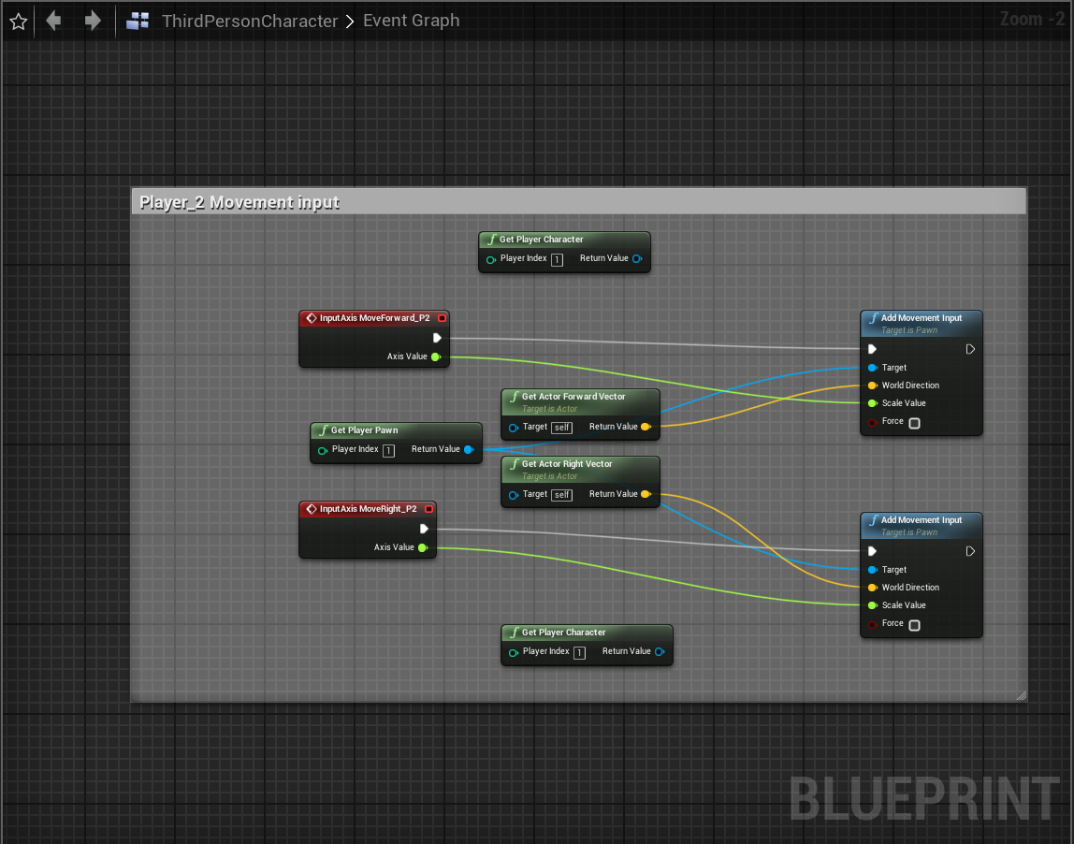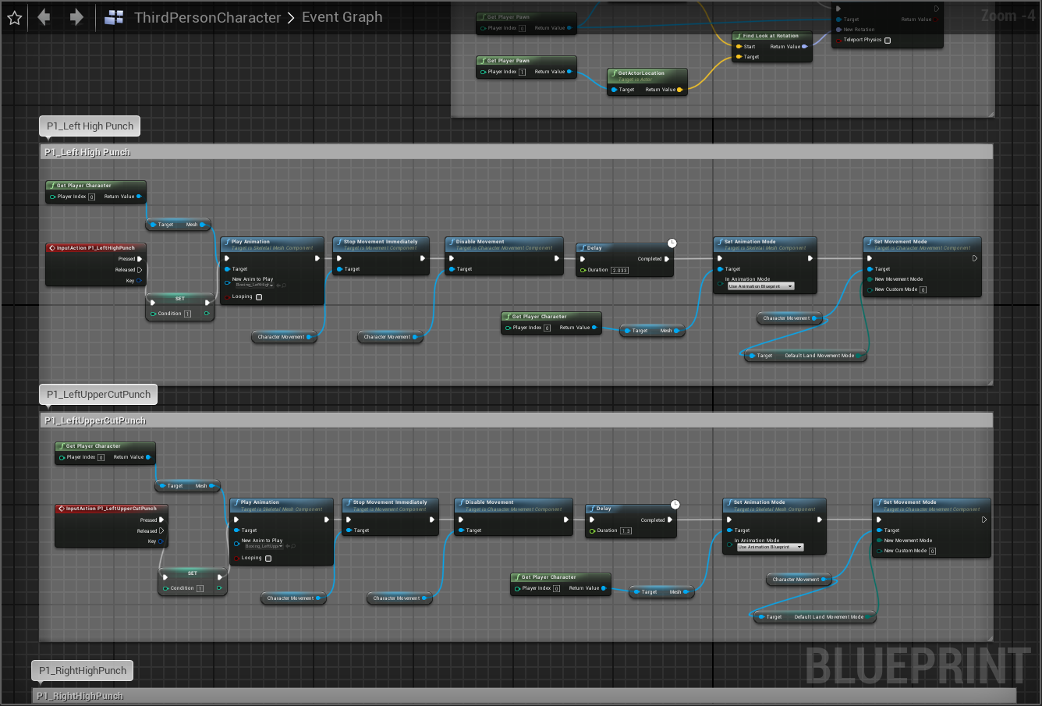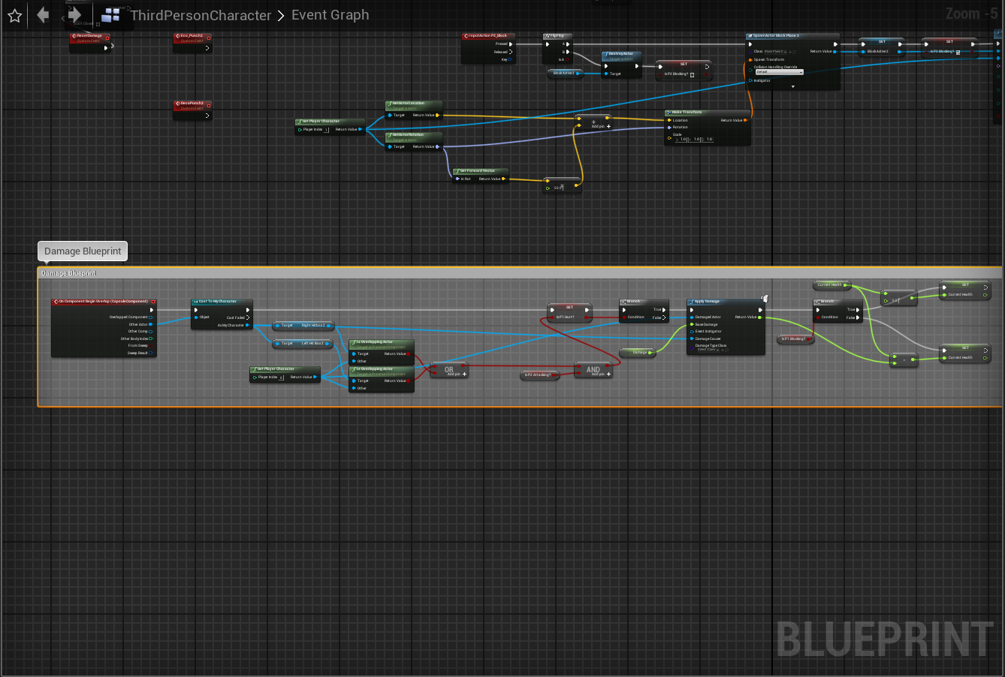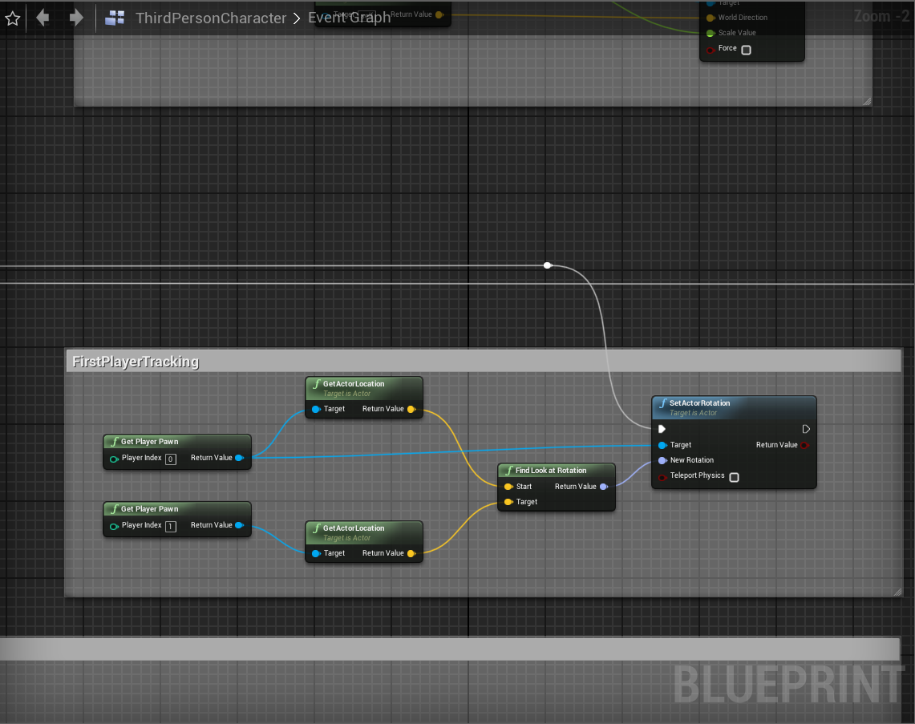

Screenshot of the level:

